First Year Project Report:
Disentangling Mechanisms of Impulsivity in the IMAGEN Data
Daniel Scott

Introduction
A substantial literature supports the notion that the basal ganglia perform an action-selection function, especially in ambiguous or novel environments. One well established account posits that cortical areas ‘select’ candidate actions (in given contexts) and ‘present’ these actions to the striatum, which has sub-populations coding for and against their execution (termed ‘go’ and ‘no go’ populations respectively). These sub-populations have different responses to dopamine, with the ‘go’ population being depolarized, and the ‘no-go’ being inhibited, and they jointly act on a downstream target, the globus pallidus, to ‘gate’ a selected action out to the thalamus and thereby enable it’s execution. The globus pallidus also receives input from the subthalamic nucleus (STN) however, which is believed to represent a non-specific ‘degree of caution’ signal, used to slow the action selection process when caution is indicated.

On the basis of this account then, there are at least two apparent routes for the suppression of actions one might consider: one mediated by the competitive internal dynamics of the striatum, and one arising from the “brake” applied by the subthalamic nucleus. This suggests that differences in individuals’ propensity to recruit these mechanisms may correspond with observable differences in the tendency to act, and specifically that making insufficiently well considered actions may arise independently from at least two mechanisms: First, individuals with biased striatal encoding of the prospective gains associated with actions (relative to potential losses) may exhibit risky behavior and second, the same may be true for individuals with typical action value encoding but poor “evidence threshold setting” mediation by the subthalamic nucleus. Each of these mechanisms is supported by studies of individuals with Parkinson’s disease, but it remains to be seen whether they also contribute to variation in impulsive behavior across individuals in other populations.

To test these hypotheses - that increased trait impulsivity will arise from separable contributions to decision-making mediated by the striatum and STN - we ask two related questions using a large (~2000 subject) population-slice sample of adolescents’ data (see methods): First, are the behavioral tasks available, specifically the stop signal (SST) and monetary incentive delay (MID) tasks, diagnostic of underlying differences in neural function across individuals? And second, are these differences in function predictive of clinical metrics of impulsiveness? To answer them, we split the data into ‘hold-out’ and ‘sandbox’ subsets (50% each), subsequently divide the ‘sandbox’ set into ‘training’ and ‘test’ sets (25% of the total each), and perform analyses on the former prior to testing for replication in the latter. The MID and SST are modeled using hierarchical Bayesian models (see methods), and the neural data is processed as region of interest (ROI) average activations and contrasts using AFNI. In addition to these primary analyses we have also performed a number of supplementary ones, to characterize the distributions of subjects’ data, the covariation among ROI activities, the degree to which subjects can be meaningfully clustered, the stability of the various metrics used over time, and relationships with genetic and personality data. Most of these are not discussed here, because either a) they have been inconclusive as of yet, b) require updating to conform with other more recent analyses, or c) simply have no place in the primary arguments presented.

Results
Subject-level parameter distributions recovered from the stop-signal task reflect typical go and stop signal reaction times, in both training and test sets (figure 1). Estimates of post-stop-signal reaction time changes did not yield the expected results however; We expected to find evidence of increased RTs immediately after stop trials as a decaying effect of modified evidence bounds, whereas instead we generally see faster RTs. This is likely an effect of a task feature that had previously gone unnoticed, namely that stop trials are approximately periodic, occurring once on every 4th-6th trial or so. As a result, participants can safely assume after each stop trial that the next few trials will not contain stop signals and use this information to modulate their reaction times. The parameters we recover are predictive of stop-go activity contrasts in a number of our a-priori ROIs, which have previously been associated with the task. Specifically, we find significant regression weights for linear models of activity in the right inferior frontal gyrus (rIFG), right pre-supplementary motor area (rPreSMA), right globus pallidus internal segment (rGPi), and right globus pallidus external segment (rGPe). Notably however, we do not find significant weights in the model of STN activity as a function of task parameters. There are multiple potential reasons for this, which are discussed below along with the other ROI analyses.

For the MID task we also recover reasonable parameters, giving reaction times on the order of 260ms with small modulations in tens of milliseconds by condition. It is not clear why these should be significantly faster in general than RTs in the stop-signal task however, given the stop-signal periodicity discussed above. A naive hypothesis is that these RT increases are a function the overall task reward rate difference (i.e. the SST has no extrinsic rewards), and this difference could itself be a meaningful biometric. Further investigation will be necessary to make any substantive claims however. Regardless of this matter, we do find that the parameters we recover here are predictive of high-reward to no-reward contrast activity in the ventral striatum (VS) in the ‘training’ subset, but this result did not replicate in the ‘test’ subset (figure 2).

Evidence for dissociable ventral striatal and STN strength axes influencing decision-making, assessed according to between-task regressions, is mixed. A regression of the SST parameters on the ventral striatal contrast activity in the MID task returns insignificant weights, which is replicated in the test set. However, the pattern of weights across both subsets suggests that increased go reaction times and decreased go reaction time variability may be related to increased contrasts, and in the agglomeration of test and training data, the relationship with go reaction times becomes significant. Here again, more investigation will be needed, although the relationship with reaction times is also suggested by non-significant regressions on MID parameters. That these estimates of reaction time distributions are also predictive of increased preSMA, GPe and GPi contrast activity per the canonical stop network however (discussed in SST details below) does suggest that the tasks have overlapping rather than distinct diagnostic power. As noted in the discussion section, such a relationship will be clarified by expanding the MID task analyses and making it more analogous with that performed on the SST.

Finally, we do not find evidence that clinical metrics of impulsive behavior can be predicted on the basis of the ROI activity in the MID task or SST. This is discussed extensively in the “limitations regarding translation” section, and further work here is needed.

Details of the Stop Signal Task Analysis
In the stop signal task we, replicate previous findings that lower stop signal reaction times (SSRTs) correspond with greater increases in rIFG activity in stop versus go conditions (figure 3). This replicates in the ‘test’ data, and hence is highly significant in the aggregation of both subsets, supporting the established view of stop-signal task network activity. We find the same relationship with the preSMA contrast, with the additional result that increased go reaction times also predict a greater difference in activity between conditions (figure 4). This could be interpreted as a consequence of consistently higher action thresholds, which would be consistent with greater caution and hence potentially hyperdirect pathway activity, but requires further investigation.

In the right STN, we find marginal relationships with post stop-signal speeding but notably not SSRT in both training and test sets. Two reasons for this are plausible: The first possibility is that, because the task is highly predictable, with stop-trials occurring consistently at approximately 4-6 trial intervals, STN activity is being modulated slowly over multiple trials given the probability of a stop-signal occurring. This hypothesis is testable with minor further modifications of the BEESTS model. In particular, incorporating a parametric modulation of RT on the basis of stop likelihood and incorporating a similar regressor in the fMRI analysis may provide evidence for such a hypothesis. A second (and independent) possibility is that the signal to noise ratio in the fMRI data inherent in using the automated anatomical labeling atlas STN ROI may be problematically low. This second point will be addressed somewhat by re-running the analyses using the probabilistic atlas of the basal ganglia provided by Keuken & Forstmann, 2015.

In the globus pallidus we find mixed evidence for relationships with go reaction time variability and SSRT. In the GPe, decreased SSRTs significantly correspond with greater activity contrasts, and increases in go reaction time variability are marginally correlated with this activity as well (figure 5). It is plausible that this reflects feed-forward activity coming from the preSMA, considering the pattern of weights is similar, but resolving the questions of STN activity posed above will be necessary to establish a solid interpretation of this. Another possibility is that go reaction times are negatively correlated with their own variability, either in general or in a subset of subjects which is driving the observed effects. This does not seem likely but which I have not yet investigated. Interestingly, the GPi contrasts have the same relationship with go RT variability that the GPe does, but without the SSRT relationship.

Multivariate methods such as canonical correlation analysis (CCA) provide another means of assessing the relationships between task parameters and activity in the stop network. I have noticed however, that changing the sets of variables and data being used do not always result in the changes to analysis outcomes which are intuitive or transparent to me, so I temporarily omit them here.

Materials & Methods
As noted above, the data used in this project come from a multi-centre, longitudinal study involving 2000 adolescents. Subjects completed a variety of questionnaire materials, performed in-laboratory behavioral tasks, were genotyped, and had structural and functional brain imaging performed at ages 14 and 18, with some out-of-lab assessments performed additionally at age 16. The task data of central importance for the analyses presented here are the stop-signal task and monetary incentive delay task, both of which were performed at ages 14 and 18 while recording fMRI activity, as well as the Substance Use Risk Profile (SURPS), Trait and Character Inventory (TCI), and delay-discounting (KIRBY) questionnaires which all include standard assessments of impulsiveness. Available data of secondary importance include the Cambridge Neuropsychological Test Automated Battery (CANTAB), Neuroticism, Extroversion, and Openness scale (NEO), Strengths and Difficulties Questionnaire (SDQ), the European School Survey Project on Alcohol and Other Drugs (ESPAD), and demographic information such as precise age at survey time, pubertal development status, verbal and reasoning IQ, body mass index, and self-report hyperactivity. These secondary components are important because impulsive behavior is believed to have relationships with gambling (assessed in CANTAB), conscientiousness (NEO), relationships with food and substance use (bmi, SDQ and ESPAD), and to potentially be related with one’s developmental time-course. As such, an analysis aiming to predict real-world impulsive behavior may stand to benefit from the additional diagnostic information regarding potential impulsiveness sub-types and manifestations. Because analyses of these secondary components have not yet been fit into the narrative of this work in a principled way, they have been omitted from the results section and further discussion.

We characterize performance on both of our primary tasks of interest (the stop signal task and monetary incentive delay task) using hierarchical Bayesian models, with parameter estimates the for the data-generating distributions sampled with PyMC. The use of hierarchical Bayesian models improves on classical parameter estimation techniques, in that group-level and individual parameter distributions are estimated in an optimal, mutually informative manner. Model convergence is checked by visually assessing trace plots, examining the subject level distributions of parameter estimates in ‘training’ and ‘test’ subsets of the data, and visual inspection of posterior densities. We also calculate the gelman-rubin statistic (ratio of inter- to intra-chain variance) and examine posterior predictive densities (i.e. generative model output) to check convergence and model appropriateness for the stop signal task.

The particular model we use for the stop signal task is a modified version of the BEESTS model (Matzke et al 2012). This model assumes motor commission and inhibition rely on independent, random completion-time processes which can be characterized by ex-Gaussian distributions. In our application, the software for this fitting this model was also partially rewritten to accommodate estimation with large number of subjects, and additional parameters were incorporated to estimate sequential effects on reaction times. These additional parameters were included with the aim of capturing trial-by-trial variation, particularly post-inhibition reaction time slowing, which is a plausible proxy for the efficacy of prefrontal-STN connectivity. Parameter estimates used in the analyses above are means over the final 1000 samples from three Markov chains each, sampled with the metropolis sampler in PyMC2. The Markov chains were produced with a burn-in of 25,000 samples and subject to a thinning factor of 5, i.e. out of 30,000 samples, auto-correlation is mitigated by keeping only every 5th parameter estimate, and of the resulting 5,000 effectively-independent samples only the final 1000 are used for analysis.

Our model for the MID task is essentially an extended linear regression model, based loosely on the LATER model (Noorani 2015). Reaction time distributions can generally be approximately with inverse gaussian pdfs, and as a result, changes in RT distributions under varying task conditions can be approximated using inverse gaussian pdfs with linear models over task condition variables as location parameters. We determined the set of condition variables to include on the basis of standard model-selection procedures, that is, by fitting each possible model given the set of conditions, evaluating the Watanabe-Aikake Information Criterion (WAIC) for each, and proceeding with the model yielding the lowest value. The model with the lowest WAIC included indicator variables for rewarded and highly rewarded conditions, a continuous variable coding the length of the anticipation period, and an intercept. This model was sampled 2,500 times for each of three chains, with 1000 samples discarded as burn in for each and no thinning, using PyMC3’s No-U-Turn Hamiltonian sampler, which is considerably more efficient than PyMC2’s metropolis sampler.

fMRI analysis was performed by fitting standard hemodynamic response functions (HRFs, 3 basis-function mixtures comprising a gamma function and it’s temporal and dispersion derivatives) to percent-signal-change transformed fMRI signal using AFNI’s 3dREMLfit tool. Preprocessing steps of affine warping onto a template, smoothing with an 8mm full-width-at-half-maximum Guassian filter, stripping, etc were performed by the IMAGEN consortium, whereas we performed motion censoring (0.3mm threshold), de-spiking, outlier removal, and statistical map generation and inspection for this analysis. Contrast activities presented above are differences of ROI averaged coefficients for the gamma function in the HRF basis set.

Finally, all data going into the analyses presented above are z-scored, except where explicitly noted otherwise, and subject to outlier removal on the basis of the median-absolute-deviation (MAD) (a robust scale estimator); Values lying more than 4.5 median absolute deviations from the median are replaced with NAs. Approximately 20/500 of fields contain one or more outliers by this criteria, and no fields contain more than a few.

Discussion
Limitations regarding diagnosis of neural function
There are a number of refinements to both the task models and the imaging pipelines which may improve the sensitivity of these analyses. Currently the ROIs under consideration are largely drawn from the automated anatomical labeling (AAL) atlas.

With regard to the MID task, two limitations are particularly apparent. The first is that model fit is currently being assessed via the qualitative observation of approximate log-linearity. The use of posterior predictive checks would be desirable. Additionally, the regression model yields parameters which are not particularly transparent summary statistics of the data, and the more transparent statistics I have computed on top of them are relatively crude. As a result, the prediction of the neural data on the basis of these items will also be relatively crude compared with the model of the stop signal task, which I have considered in much more depth. Relatedly, the fMRI measure being used here, an activity contrast in the ventral striatum, is also taken from the work of others. A more principled approach will therefore be to 1) identify a small network of MID task related regions, in a manner similar to that involved in the SST, extracting the activity using the same pipeline currently in place for the SST data, and 2) repeat the regression of contrast activities using a more thoroughly vetted model, potentially another ex-gaussian model. This will make the MID and SST results more directly comparable, as well as the parameters governing reaction time distributions. Furthermore, ongoing work looking at stop-network connection strengths and within-individual covariation will also then have direct analogues in the MID task analysis.

Limitations regarding translation:
The foremost limitation in predicting behavior from neural differences arises from the observation that Parkinson’s disease and its treatments intervene in the biology of individuals who were likely to be approximately typical (on average) prior to disease onset. This suggests that inter-regional connection strengths and structure-specific processing will have largely developed with respect to fairly stable and long term balances of activity and mutual influence. Treatment with levodopa or deep brain stimulution would then initiate novel regimes of function, imposed abruptly and in a state of low plasticity upon a system under pressure over developmental time to adapt to very different operating parameters. As such, it would not be surprising if imbalances of the type we have looked for are systematically mitigated against in the normal developmental processes of neurologically healthy individuals. Several hypotheses regarding such mitigating effects are possible: Given the hierarchical and recurrent nature of the cortical-sub-cortical connectivity under discussion, compensatory cortical changes seem likely in individuals with optimistically-biased striatal estimates of action value. In particular, such individuals may exhibit stronger “upstream” control over the set of actions are under consideration in a given circumstance. This could correspond with differences in the strength of PFC involvement along the rostral-caudal gradient, with ‘high-bias’ individuals exhibiting flatter activity gradients than individuals who do not require such pre-emptive upstream exertion of control. A related behavioral hypothesis could be that such individuals would use of behavioral strategies and pro-active regulation of their environments as a means of off-loading cognitive labor insofar as they are effective at mitigating a bias towards impulsivity, a possibility with potentially interesting relationships to other forms of implicit cognitive strategy such as relying on communities of knowledge or self-modulatory behavior such as sensation seeking.

A second significant potential limitation of the approach used here is the potentially low construct validity of impulsiveness as assessed by available metrics. Inter-assessment agreement is only modest, with individuals qualifying as highly impulsive on some scales and atypically controlled on others. Principal components analyses of these measures do not suggest clear linear subspaces capturing some critical dimensions of variation. This suggests both the construction of more nuanced latent variable models of impulsiveness, encoding more structured beliefs about the relationships between the assessments, and potentially the use of a estimation schemes which incorporate the neural and/or task data explicitly in the determination of such relationships. These are potential future directions.

Bibliography
Imran Noorani, R.H.S. Carpenter, The LATER model of reaction time and decision, In Neuroscience & Biobehavioral Reviews, Volume 64, 2016, Pages 229-251, ISSN 0149-7634, https://doi.org/10.1016/j.neubiorev.2016.02.018.

Keuken, M. C., & Forstmann, B. U. (2015). A probabilistic atlas of the basal ganglia using 7 T MRI. Data in Brief, 4, 577–582. https://doi.org/10.1016/j.dib.2015.07.028

Matzke, D., Dolan, C. V., Logan, G. D., Brown, S. D., & Wagenmakers, E.-J. (2013). Bayesian parametric estimation of stop-signal reaction time distributions. Journal of Experimental Psychology: General, 142(4), 1047–1073. https://doi.org/10.1037/a0030543
Figures:
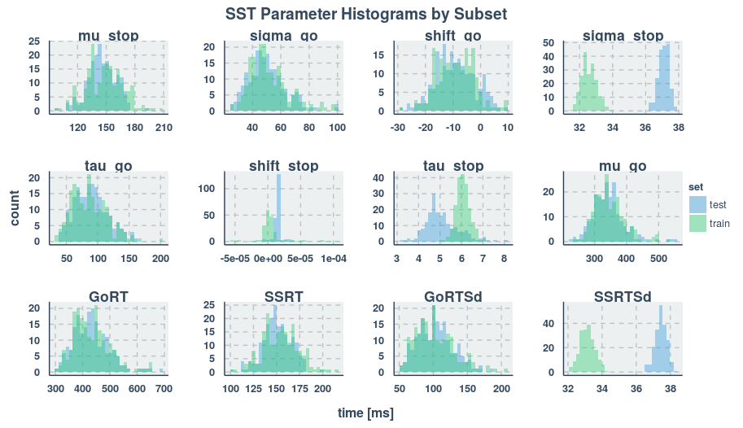
Figure 1: Recovered subject-level parameters for the stop-signal task. Mu and sigma refer to mean and standard deviation in the Guassian components of the task model, and tau refers to the decay rate of the exponential distribution. "Go" parameters refer to "go" RT distributions whereas "stop" parameters reference the control process. "Shift" parameters refer to changes in the ex-gaussian means as a function of trials which occur immediately after stop-trials. GoRT and SSRT are calculated as mu_go + tau_go and mu_stop +tau_stop respectively, with modulation by shift_go and shift_stop on the basis of previous trials’ type.

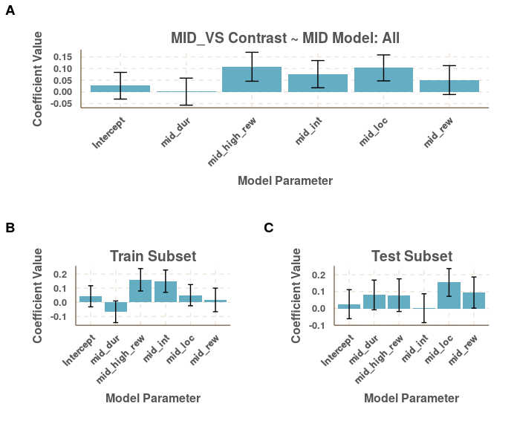
Figure 2: Ventral Striatal activity contrast of high-reward - no-reward conditions, modeled as a linear combination of MID task parameters. The parameters themselves control the degree to which inverse reaction times are modulated by task conditions. Increases in value therefore corrospond with shorter reaction times. "mid_dur" parameterizes changes according to anticipation period duration, "high_rew", "loc", and "rew" parameterize the 'stakes' of the trial and the left-right location of the target onscreen, and "int" is the mean reciprocal RT.
In the training data, mid_high_rew has p=0.046 and mid_int has p=0.060. In the test data mid_loc has p=0.063, and in the agglomerated data high_rew has p=0.084, mid_loc has p=0.065, and mid_int has p=0.2. Error bars are SEs.

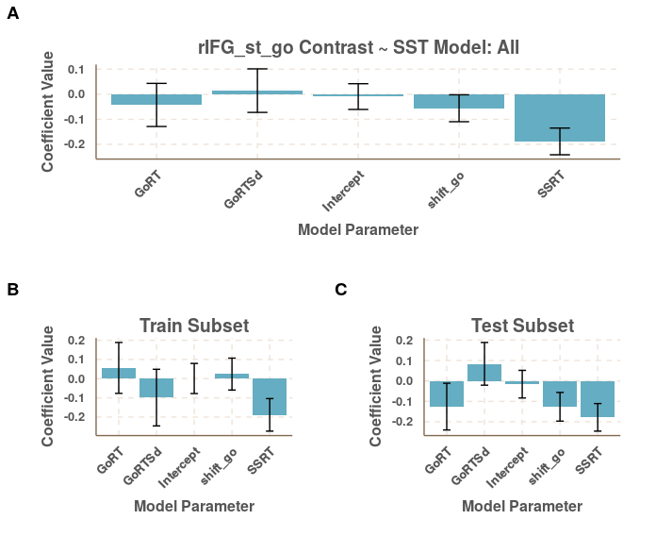
Figure 3: Contrast of right inferior frontal gyrus activity between stop and go conditions (stop - go) as a function of SST task parameters.
In the training subset, SSRT p=0.028, in the test set SSRT p=0.009, and in the agglomerated data, p=0.005. Error bars are SEs.

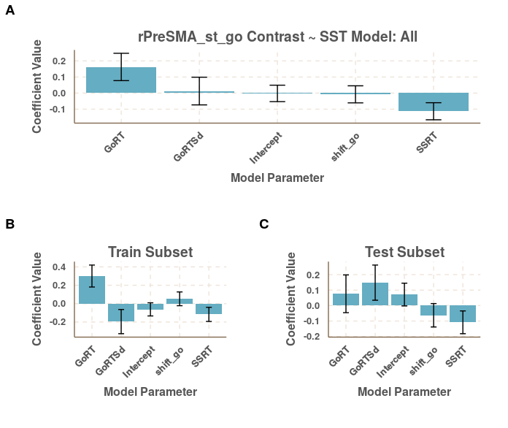
Figure 4: Contrast of right pre-supplementary motor area activity between stop and go conditions (stop - go) as a function of SST task parameters.
In the training subset the GoRT weight has p=0.013 and SSRT p=0.132, whereas p values in the test subset are > 0.05 and in the agglomerated data GoRT p=0.056 and SSRT p=0.034. Error bars are SEs.

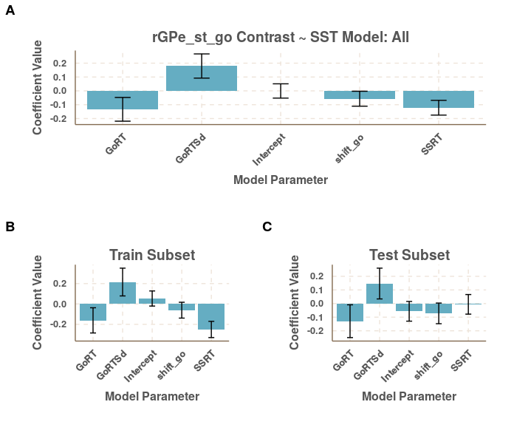
Figure 5 Contrast of right GPe activity between stop and go conditions (stop - go) as a function of SST task parameters.
In the training subset the GoRTSd weight has p=0.116 and SSRT p=0.002, whereas p values in the test subset are > 0.05. In the agglomerated data GoRT p=0.041 and SSRT p=0.023. Error bars are SEs.

It is important to note that everywhere ‘training’ and ‘test’ subsets are discussed here, they are references to subsets of the ‘sandbox’ set, and therefore would both be considered ‘training’ sets in a stricter, standard application of the terms – the use adopted here is for describing approximate internal replication. For the rest of the discussion, it will be pretended that the hold-out set does not exist. These splits were actually performed on a relatively complete subset of the data, so that actual numbers are ~198 subject in the test and training sets each, with some variation depending on analysis.
Two parameters contributing to individual subjects’ stop signal reaction time variability appear not to have fully converged (which is readily seen in figure 1), so subsequent analyses presented here do not make use of them. (Significantly longer Markov chains have been made run but not yet processed.)
That is, convolutions of exponential and gaussian pdfs. These are non-negative and skewed, similar to gamma or inverse gaussian distributions.
The validity of this approximation is verified by noting the linearity of RT CDFs on a log plot.

